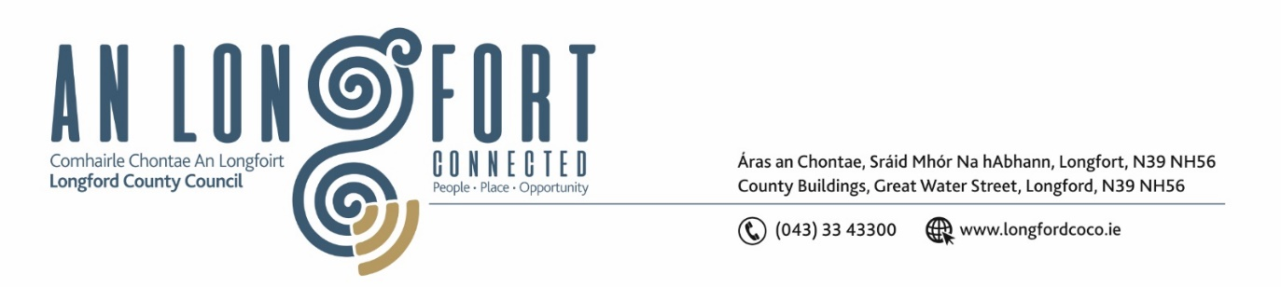

**GRANARD MUNICIPAL DISTRICT**

**Minutes of Meeting of Granard Municipal District held in Granard Library**

**on Tuesday, 23 May 2023 at 3.30pm**

**CATHAOIRLEACH**: Councillor Colin Dalton

**MEMBERS PRESENT**: Councillors – Paraic Brady, PJ Reilly, Garry Murtagh and

Turlough McGovern

**IN ATTENDANCE**: Ms. Mary Gouldsbury

Ms. Linda Higgins, Administrative Officer

Mr. David Coppinger, Senior Executive Engineer

**APOLOGIES** Ms Barbara Heslin, Director of Services

**A/MEETINGS**

**ADMINISTRATOR**: Mr Gerard Dennigan

1. **ADOPTION OF MINUTES – circulated**
2. On the proposal of Councillor Paraic Brady seconded by Turlough McGovern, it was unanimously agreed to adopt the Minutes of Granard Municipal District Meeting held on the 24 March 2023.
3. On the proposal of Councillor Turlough McGovern seconded by Paraic Brady, it was unanimously agreed to adopt the Minutes of Granard Municipal District Committee Meeting held on the 24 March 2023.
4. **MATTERS ARISING FROM MINUTES**

None.

1. **DECLARATION OF INTEREST BY MEMBERS**

None.

1. **MANAGEMENT REPORT INCORPORATING AREA ENGINEER’S PROGRESS REPORT – circulated**

Mary Gouldsbury highlighted the following from the Management Report and responded to the queries raised by the Elected Members:

* Longford Tourism
* Housing Update
* Regeneration

David Coppinger detailed the Area Engineer’s Progress Report and responded to the queries raised by the Elected Members –

* General Roadworks
* Local Improvement Schemes
* Granard Town Works
* Dring Amenity Works
* Higginstown Sport Complex

The members unanimously acknowledged the work to date completed in the Granard MD and expressed there thanks to David and his team.

Councillor Paraic Brady requested an update on the trial from Monaduff to Ballinamuck and if a contractor appointed.

Councillor Colin Dalton sent his best wishes to Longford in the Tailteann Cup.

1. **COMMUNITY GRANT SUPPORT SCHEME 2023**

Linda Higgins briefed the members on the 2023 Community Grant Support Scheme.

It was recognised at the meeting that several new groups submitted applications. The members complimented the Community Groups on their interest in this scheme and thanked them for the voluntary work they undertake. The grants will be of significant benefit to their communities.

Conflict of interest was noted for Councillor Garry Murtagh.

On the proposal of Councillor Paraic Brady and seconded by Councillor Turlough McGovern €500 was awarded to an additional Community Group. It was agreed that 50% of one application be referred to Longford MD for its consideration. It was also agreed balances on two other applications be referred to the County wide fund.

On the proposal of Councillor PJ Reilly and seconded by Councillor Paraic Brady the members unanimously agreed the Community Grant Support Scheme for 2023 to a total of €55,065.

On the proposal of Councillor Paraic Brady seconded by Councillor Garry Murtagh, it was unanimously agreed following today’s grant approvals that €6,086.00 be transferred from the Tidy Towns sub service budget to cover the shortfall in the Voluntary Bodies sub service budget.

1. **GMA 2023 - SPECIAL PROJECTS/DISCRETIONARY FUNDS**

**Councillor Colin Dalton**

On the proposal of Councillor Colin Dalton seconded by Councillor Turlough McGovern, it was unanimously agreed that

* €500.00 be allocated to Mostrim GAA
* €500.00 be allocated to Pony Show Ballinalee.
* €500.00 be allocated to Ballinalee Tidy Towns
* €500.00 be allocated to Ballinamuck 1798 Commemoration

**Councillor Turlough McGovern**

On the proposal of Councillor Turlough McGovern seconded by Councillor Paraic Brady, it was unanimously agreed that

* €500.00 be allocated to Rath Mhuire Doimen Group Granard.
* €500.00 be allocated to Abbeylara Defibrillator Committee
* €500.00 be allocated to Abbeylara Tidy Towns
* €500.00 be allocated to Ballinamuck 1798 Commemoration

**Councillor PJ Reilly**

On the proposal of Councillor PJ Reilly seconded by Councillor Turlough McGovern, it was unanimously agreed that

* €500.00 be allocated to Ballinamuck 1798 Commemoration

**Councillor Paraic Brady**

On the proposal of Councillor Paraic Brady seconded by Councillor Colin Dalton, it was unanimously agreed that

* €1000.00 be allocated to Ballinamuck 1798 Commemoration

**Councillor Garry Murtagh**

On the proposal of Councillor Garry Murtagh seconded by Councillor Turlough McGovern, it was unanimously agreed that

* €500.00 be allocated to Ballinamuck 1798 Commemoration

1. **NOTICE OF MOTIONS, SUBMITTED BY COUNCILLORS:**

**The following notice of motion was proposed by Councillor Paraic Brady and seconded by Councillor Colin Dalton**

I call on Longford Roads section to mark the crossroads at Hagan’s cross in Killoe and put a single white line up into and beyond the village and if possible as far as the national school in Killoe. This stretch of road allows people to pass going through the village where there's a pub, church, shop and play area.

**Response:**

**Response from Road Design section.**

The distance from Hagans Cross to the National School is approximately 1.7Km and in this section of road there are a number of distinct sections. Within the village core there is a built up section where it is not recommended that continuous centre lines are provided due to the requirement to cross the centre line to access properties or parking etc. Outside that there are straight sections with adequate visibility where overtaking may be safe, and other areas where overtaking will not be safe (crest of a hill, bend, …) and possibly narrow sections where centre lines are not advised.

The Area staff will review the section of road and will provide centre line markings in accordance with the guidance provided in the Traffic Signs Manual and within the limitations of the budgets available for line marking.

It should be noted that introducing continuous centre lines in areas where they are not warranted will reduce the availability of overtaking locations which will put pressure on drivers at these locations with resultant increased speeds or attempts to overtake at other locations where overtaking may not be appropriate.

**The following notice of motion was proposed by Councillor PJ Reilly and seconded by Councillor Paraic Brady**

I wish to put a motion to the meeting for the Council to write to TII Roads Authority to construct a relief road on the N55 on the Cavan North side of the town of Granard to connect with the Athlone South side of the town to help to relieve the large amount of congestion and heavy traffic passing through the town.

**Response:**

Following agreement by the Members, Longford County Council will write to Transport Infrastructure Ireland in relation to this project

**The following notice of motion was proposed by Councillors Colin Dalton and Paraic Brady and seconded by Councillor Paraic Brady**

We call on Longford County Council through the Regeneration team to refresh the walkway on Cairn Hill.

**Response:**

The Elected Members approved an allocation in the 2023 budget for the maintenance and upkeep of greenways and walkways. This allocation includes a contribution to Waterways Ireland for the upkeep and maintenance of the Royal Canal Greenway. Any additional works will be assessed, prioritised, and carried out by Longford County Council.

The Regeneration Section of Longford County Council will review the works required and will carry out some minor surface repair works there in the next 2 to 3 weeks.

**The following notice of motion was proposed by Councillor Colin Dalton and seconded by Councillor PJ Reilly**

1. I call on Longford County Council to distribute the funding that was allocated in budget to maintain our walkways.

**Response:**

The Elected Members approved an allocation in the 2023 budget for the maintenance and upkeep of greenways and walkways. This allocation includes a contribution to Waterways Ireland for the upkeep and maintenance of the Royal Canal Greenway. Any additional works will be assessed, prioritised, and carried out by Longford County Council.

**The following notice of motion was proposed by Councillor Colin Dalton and seconded by Councillor Turlough McGovern**

1. I call on Longford County Council to repair any damaged road signs in the Killoe, Ballinalee, and Clonbroney areas.

**Response:**

Where we are notified of signs that are damaged/missing, we will endeavour to replace/repair them within the limits of the Maintenance Budgets we have available. I am aware of some signage missing from Esker Cross and we will try to get these repaired/replaced this summer.

**The following notice of motion was proposed by Councillor Turlough McGovern and seconded by Councillor PJ Reilly**

I call on Longford County Council to write to Minister Darragh O’Brien to highlight the current crisis in recruitment and retention of Retained Firefighters, especially in Granard which ultimately lies with Government policy, and seek an increase in capital investment for County Longford.

**Response:**

The concerns outlined in the Notice of Motion are National issues, impacting on all Local Authorities in the recruitment and retention of Retained Firefighters.

Following agreement by the Members, Longford County Council will write to Minister Darragh O’Brien highlighting the concerns of the Elected Members.

**Votes of Sympathy**

The members sympathised with Councillor Gerard Farrell on the recent passing of his mother Josephine Farrell – RIP

The members sympathised with the family of the late Johnny Lynn, Main Street, Edgeworthstown, Co. Longford. R.I.P

The members sympathised with the family of the late Seanie Reilly, Cloonaugh, Drumlish, Co. Longford. R.I.P

This concluded the business of the meeting.

**Signed: ____________________**

**Gerard Dennigan**

**A/Meetings Administrator.**

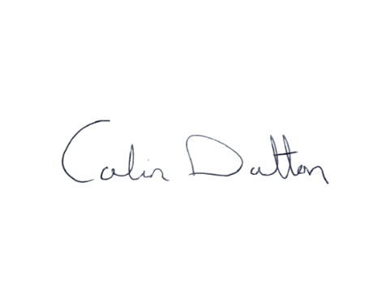

**Confirmed and adopted at Granard Municipal District Meeting held on the 25 July 2023.**

**Signed: _______________**

**Cathaoirleach.**